1998 Lund Pro V SE
And single axle Trailer
FOR SALE
- 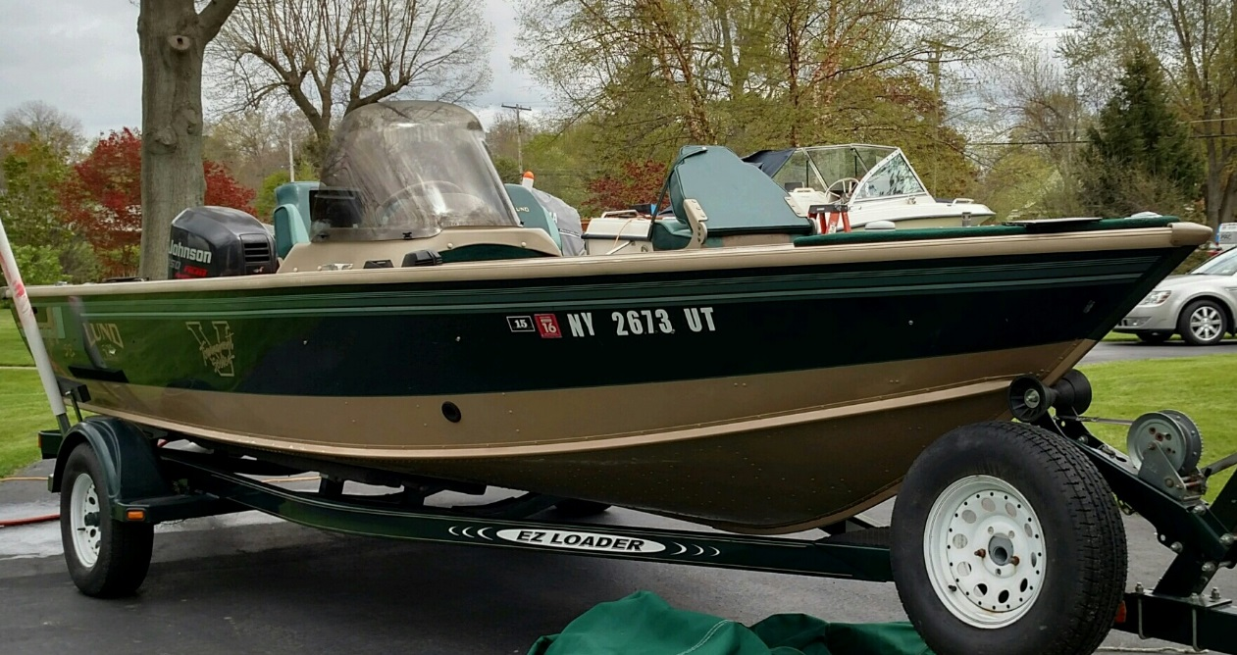
- Hull Aluminum Length 20’, Model Pro V SE 1900
- 1998 Johnson 150HP

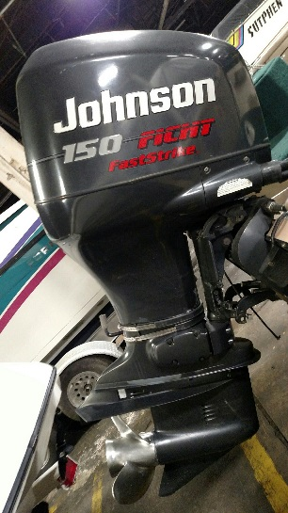
- 6hp Mercury Kicker Motor (Pull Start)
- Spare Prop, Custom Wheels, Spare Tire
- Minn Kota Trolling Motor (Auto Pilot)
- Call or text 716-940-2845 $13,000

