7th Annual Fishermen’s Paradise Flea Market / Swap Meet | 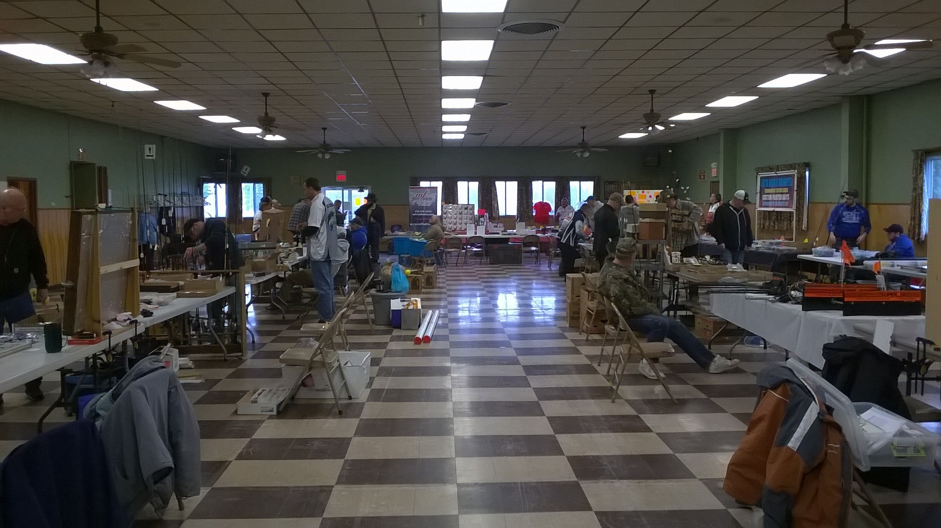
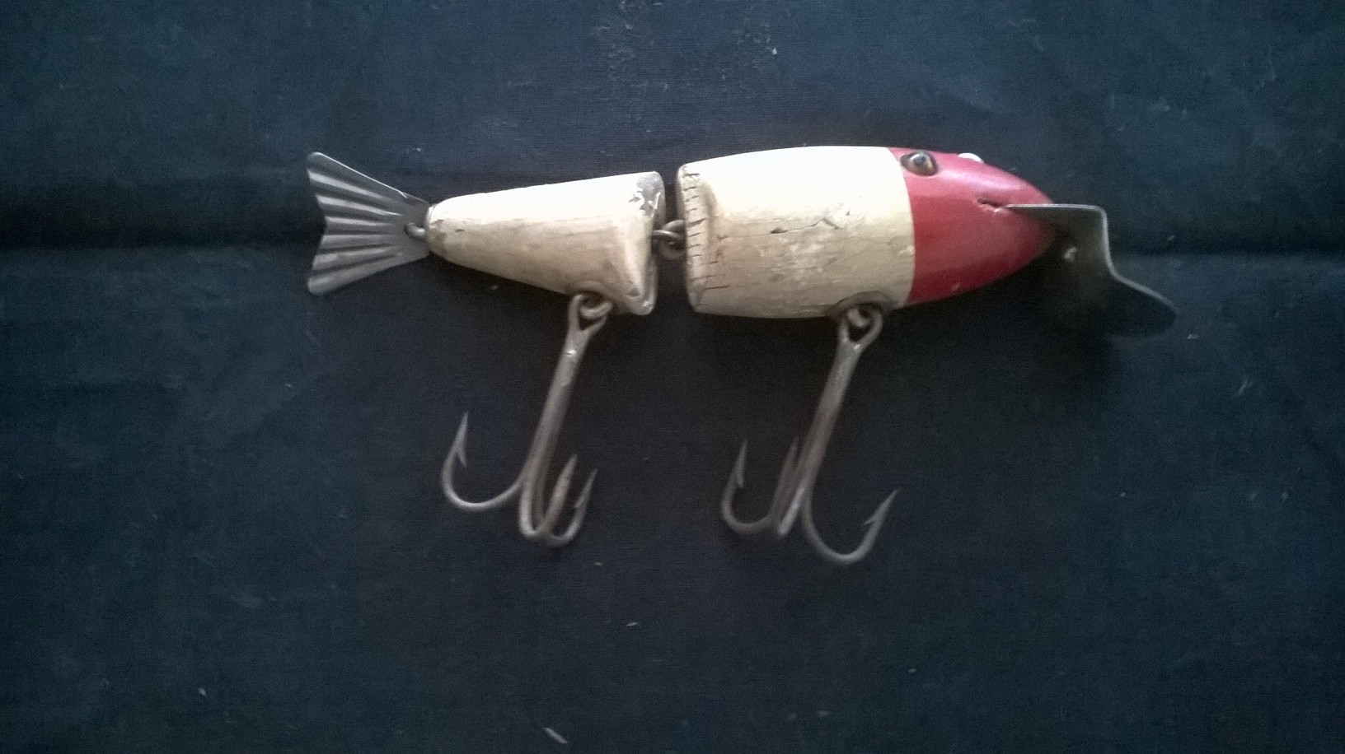 | 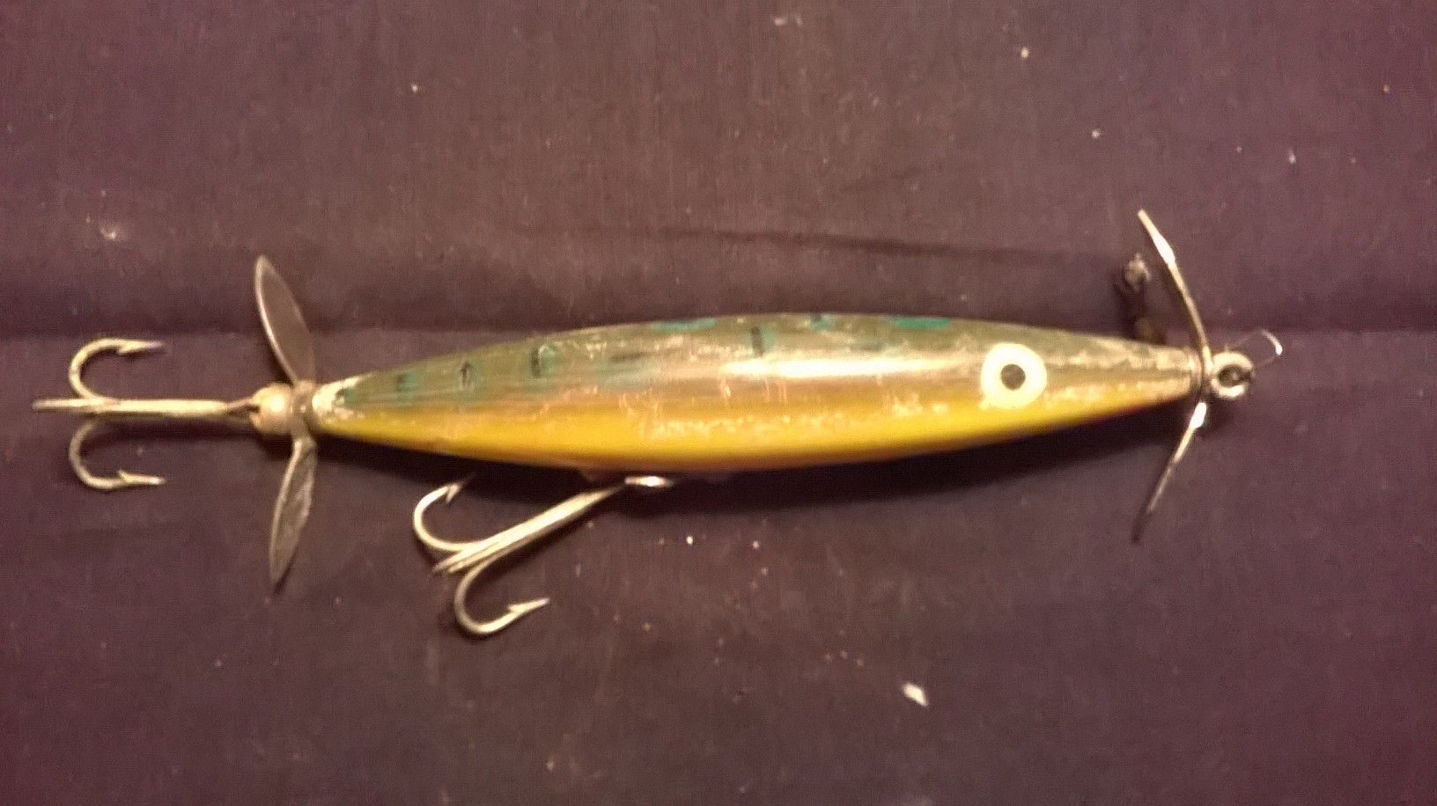

Saturday March 24, 2017 9am – 2 pm. Alexander Fire Hall 10708 Rt. 98, Alexander, NY 14005. Admission charge. No early entries.

