Genesee Charter Boat Assoc. 5th Annual Flea Market | 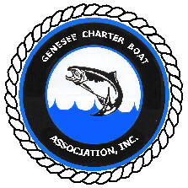
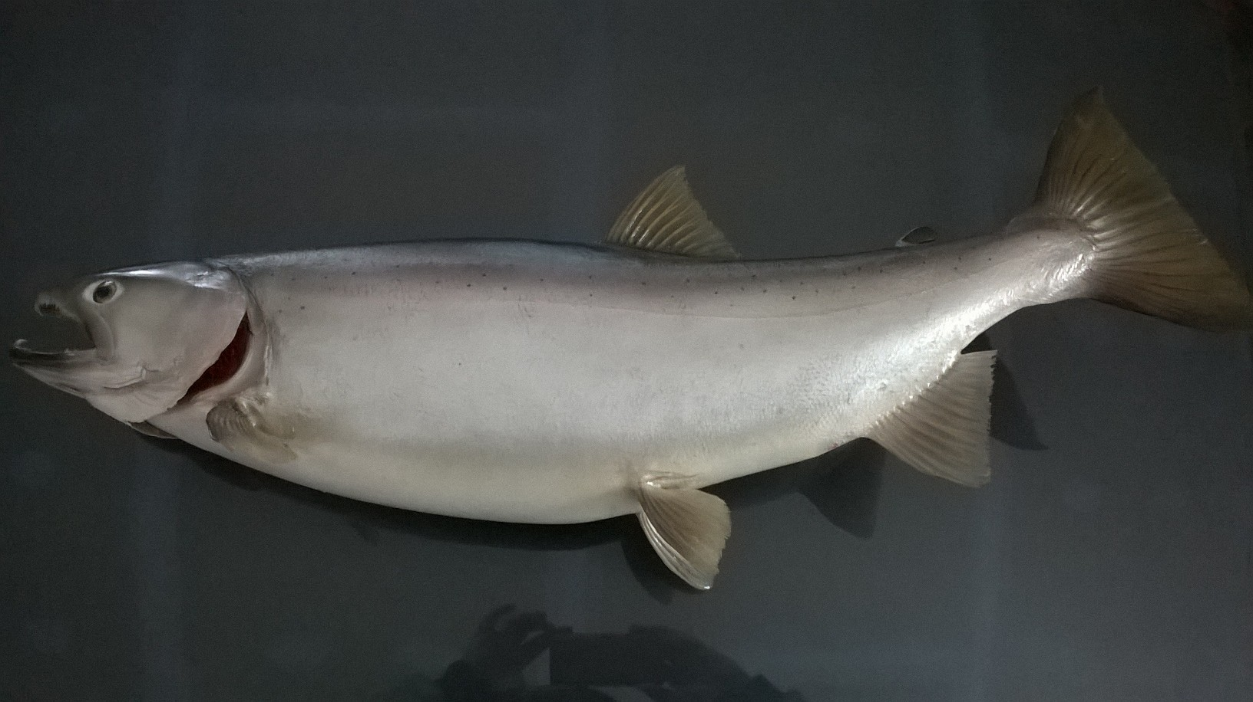 | 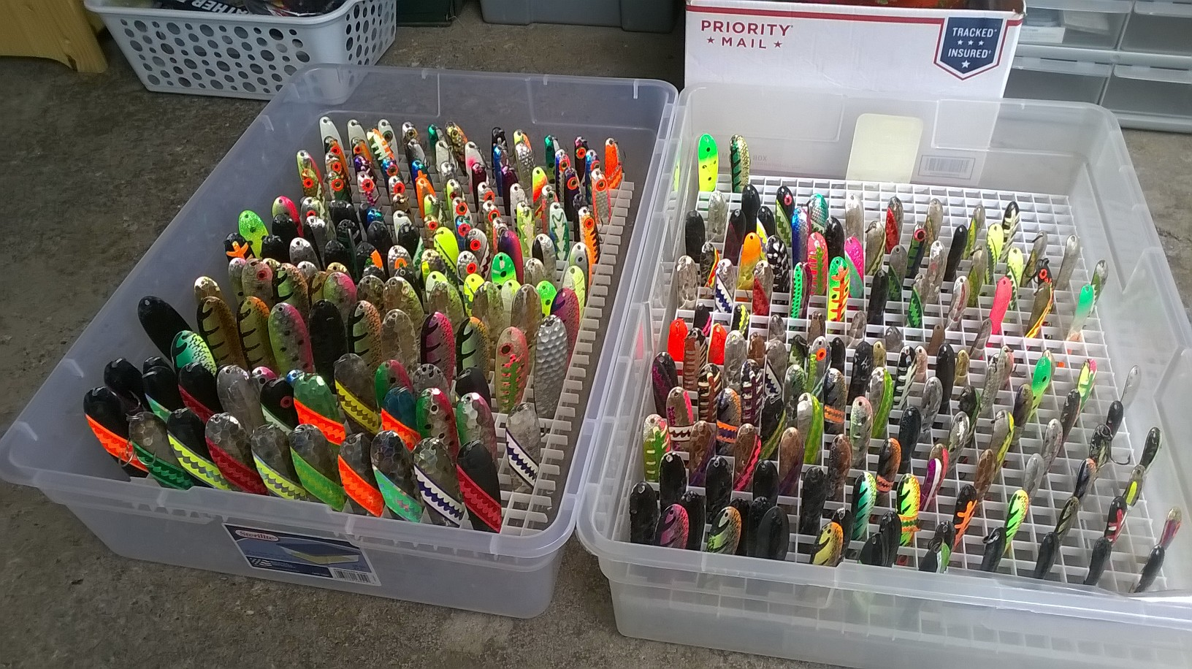

  - Pt. Pleasant Fire Hall
  - 55 Ewer Ave, Rochester, NY 14622
  - Sunday March 10, 2019 9:00-2:00pm
Come on down and haggle with the captains and get some great deals, or pick their brains for some tips on being successful on the big lake. Some proceeds go to the pen rearing project and the fire department. No early admission. We are sold out with 31 tables of fishing related gear. Hope to see you all there.

