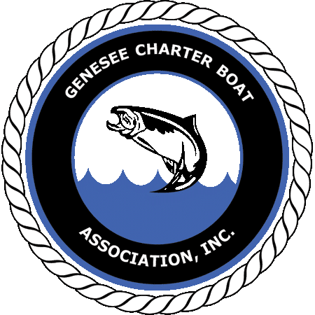
2019 Monroe County Offshore Classic
Trout Salmon

This Year’s Charity is Dream Factory
"Dream Factory, of Rochester New York, is a local, volunteer organization that fulfills dreams for children diagnosed with critical or chronic illnesses."
Saturday, June 29th, 2019
Entry Fee is $200 per boat with cash payouts and percentage to Dream Factory
Sign up at:
B-E Fishing Tackle- 6275 Dean Parkway, Ontario NY 14519
Mitchel’s Bait and Tackle- 4531 Lake Ave, Rochester NY 14612
South Bay Boat and Tackle- 1350 Empire Blvd, Rochester NY 14609

Facebook “Monroe County Offshore Classic” for updates and infohttps://www.facebook.com/monroecountyoffshoreclassic/

